Deepika AG

Retail Transactional Dataset
Link: https://www.kaggle.com/datasets/bhavikjikadara/retail-transactional-dataset
AIM : To analyse customer purchasing behaviour, identify high-performing
product categories, evaluate customer spending patterns across
income groups, and generate business insights using Excel and Power
BI.
Data Pre-processing using Excel

- Removing Duplicates

Checked for Duplicates and no duplicates found, after minimising to 500 columns.

- Handling Missing Values

- From Raw Data I removed columns such as “City Tier, Phone, Address, Zipcode, Customer Segment, year, Month, Time, State, City, Product Brand, payment Method, Feedback, Order Status, Products.

- Has Missing values for the Columns “Age”, ”Gender”, “Ratings”.
a. For Numerical columns given below function.

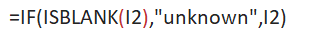
b. For Categorical Columns given below function.

- In Product Category there were Blank values. However Product type is a subcategory of Product category. Using Xlookup Formula I filled the Product category as shown below.

- Filtering and Sorting

  - For the column “K” I did sorting from Largest to smallest and gave conditional formatting to show the Highest values using Data bars.
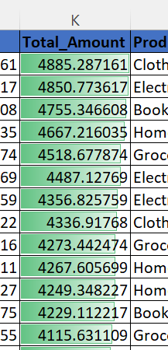

  - Formatted the Table accordingly.

- Creating Pivot Tables

  - As this is related to Customer Purchase Behaviour and Product Preferences, to understand the concept I used Pivot Tables for “Product Category” & “Gender” with Total Amount(Sales).
Sorted the Sales from highest to lowest and highlighted Top value and Bottom Value using Conditional Formatting as shown below.

The Pivot Table analysis identified Home Decor as the highest-selling
product category, while Clothing recorded the lowest sales. Gender-
wise analysis indicated that female customers purchased more Clothing
products, whereas male customers purchased more Electronics
products.
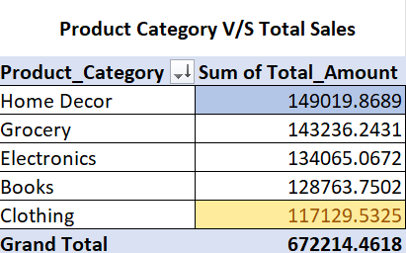

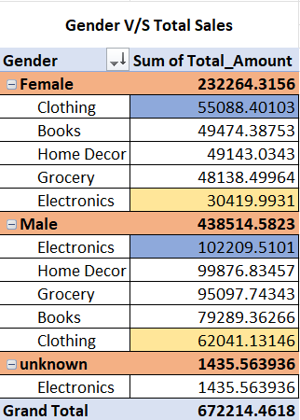

Retail Customer Purchase Analysis Dashboard
Data Visualization using Power BI

- KPI Cards
Display the overall performance of the retail business through Total Sales, Profit, YTD and Average Rating.
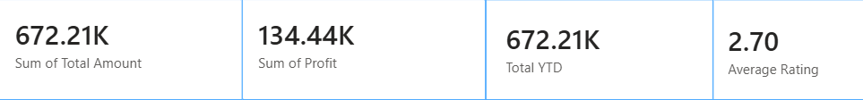

- Using Table - Top 5 Product Type-Category combinations based on Total Sales
- From “Electronics” the most Purchased item was Tablet and similarly for the rest of the categories.
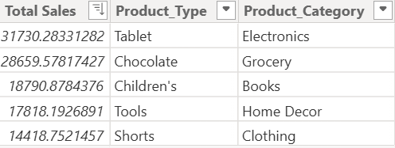

- How much do customers from different income groups spend on each product category using Stacked Column chart.

The chart shows that Medium-income customers account for the highest sales across all product categories, with Home Decor being the top-selling category.

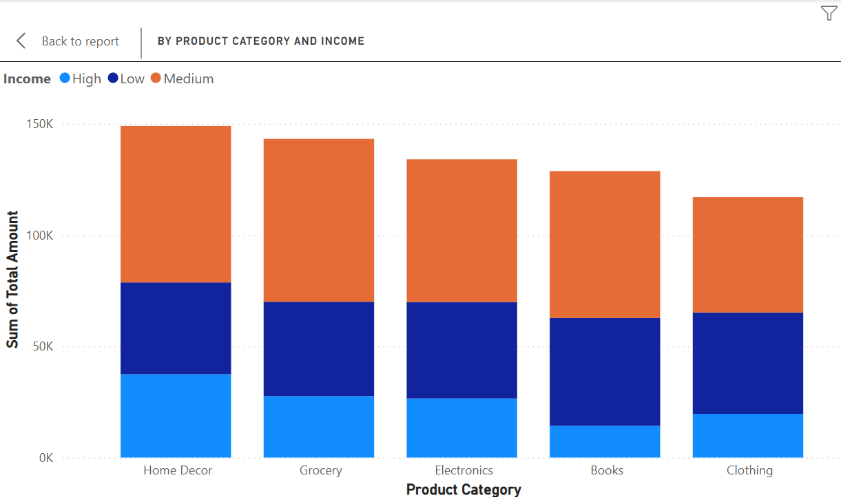

- Sales Based on Month

For the month of March , more sales has taken place.

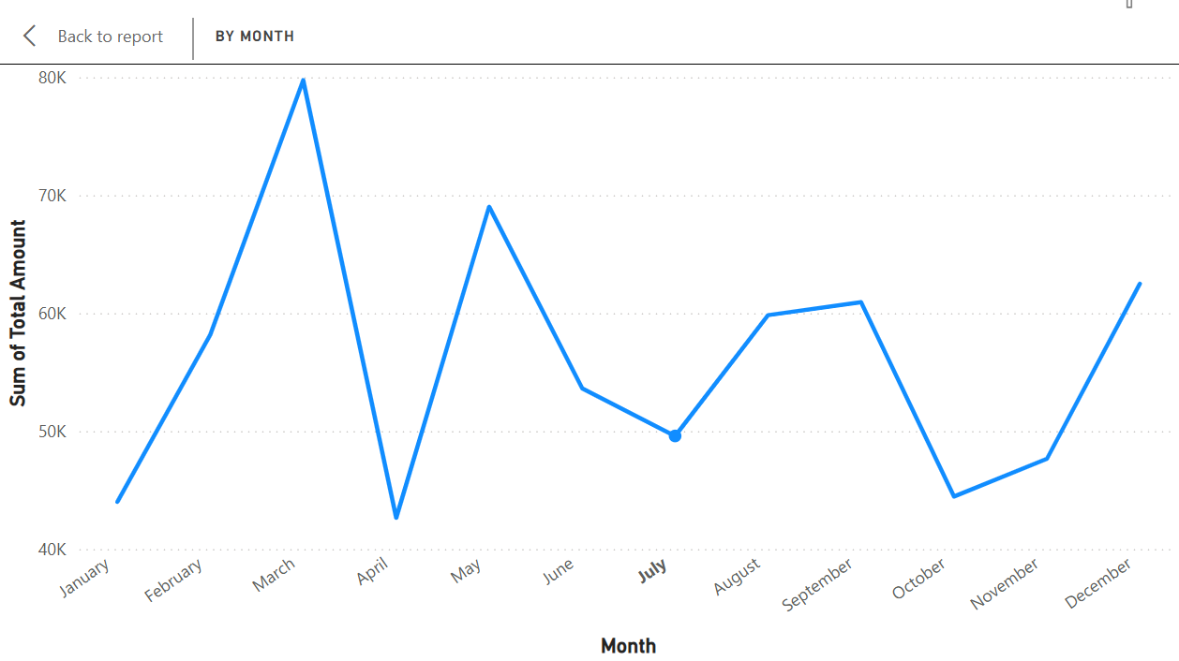

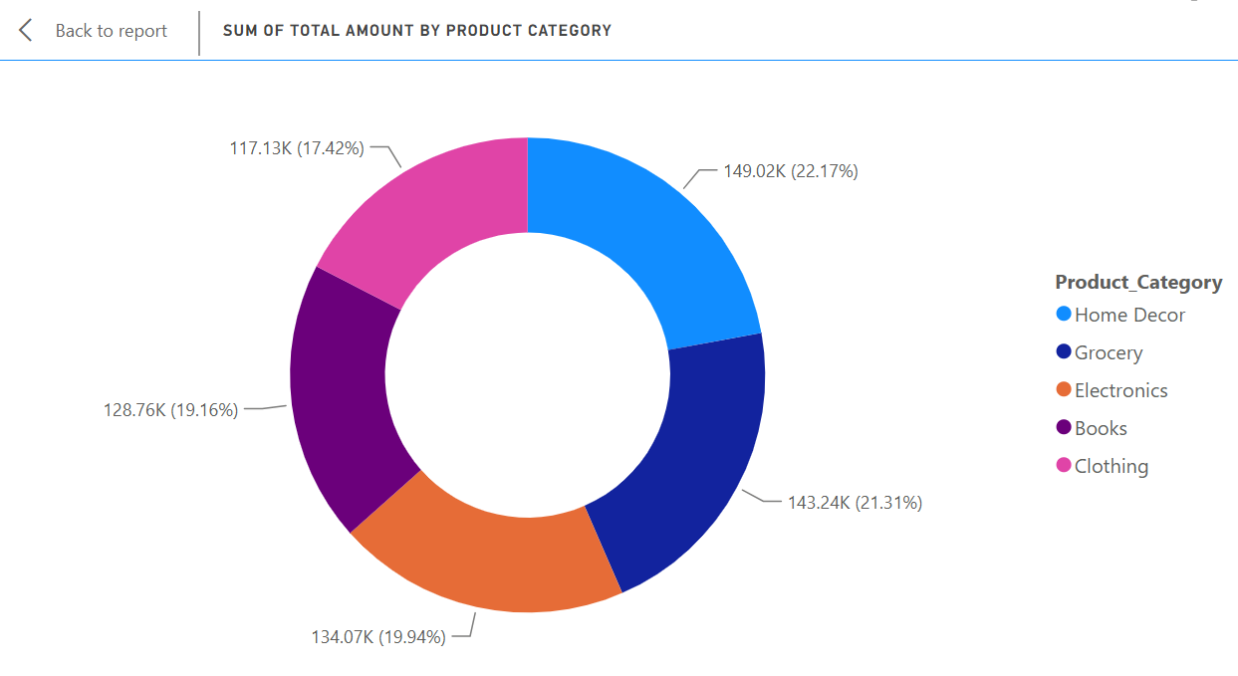
- Total amount by Product Category using Donut Chart
Home Décor was sold highest and clothing the Lowest.

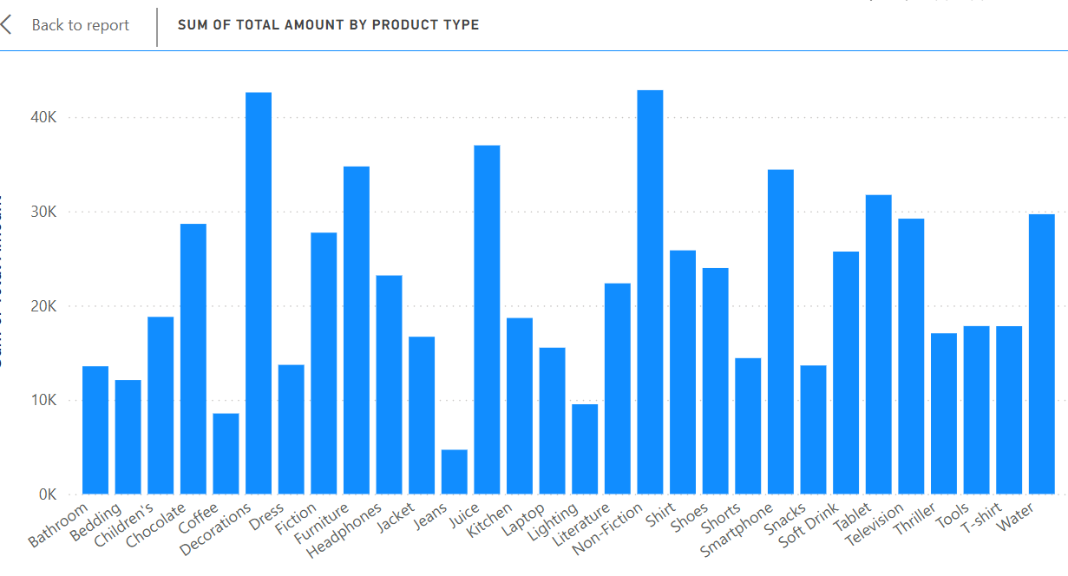
- Product Category and Product Type Hierarchy (Drill Down).
The drill-down visual enables users to move from Product Category to Product Type, making it easier to analyse sales performance at a detailed level.
- Added Slicers for Product Category and Rating
Slicers were added to enable interactive filtering of the dashboard by Product Category and Rating
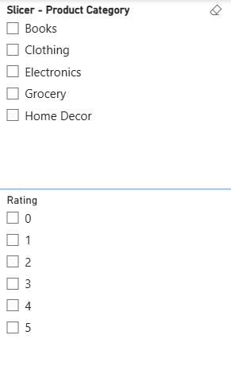

Conclusion
The retail sales analysis indicates that Home Decor is the highest-performing product category, contributing the largest share of total sales.

Customers in the Medium-income generated the highest sales across most product categories. Monthly sales peaked during March, suggesting seasonal purchasing behaviour. The dashboard enables stakeholders to monitor product performance, customer preferences and sales trends, supporting better inventory management and marketing decisions. Overall, the project demonstrates how Excel and Power BI can transform raw transactional data into meaningful business insights.

